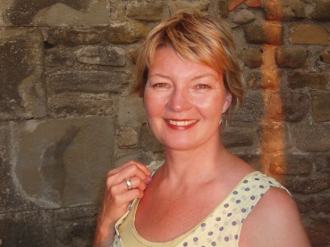
SIRIWIGDEL – BIOGRAPHY
maker – mentor - facilitator
Siri, originally from Stavanger on the West Coast of Norway, started her dance career in Germany, before further training in Manchester, UK. She moved to Wales in 1990, establishing her own practise as a performer, teacher and choreographer. Siri became instrumental in the early developments of community dance, setting up the community dance organisation Dawns i Bawb in North Wales. She became passionately involved in policy making and arts funding at a national level, leading to her appointment as Senior Dance Officer for the Arts Council of Wales from 2002-2012. In her work Siri became known for her drive in developing new initiatives supporting individual artists, helping them build sustainable career paths in Wales and internationally. One of her big achievements was the creation of Coreo Cymru, a new dance producer initiative for Wales, supported with an investment of £1 million.
Siri is using her experience of dance, funding, project management and knowledge of European art funding structures to further develop her career as a freelance arts consultant. She also makes her own work, and works with artists as a mentor and facilitator. She has been specialising in developing dance with older people, in care-home settings, and dance for people living with Dementia and Parkinson’s. Siri is a multi-lingual person and a committed Welsh learner, who relishes the opportunity to become involved in new and challenging projects, helping to find innovative solutions for a thriving and sustainable arts sector.

To contact Siri:
SiriWigdel, Bryn Haul, Pant, Penrhyndeudraeth, Gwynedd, LL48 6NB,
Tel: 01766770703 / Mob: 07855839575
siriwigdel@yahoo.com

